No XCode?

<https://replit.com/languages/swift>

Xcode:

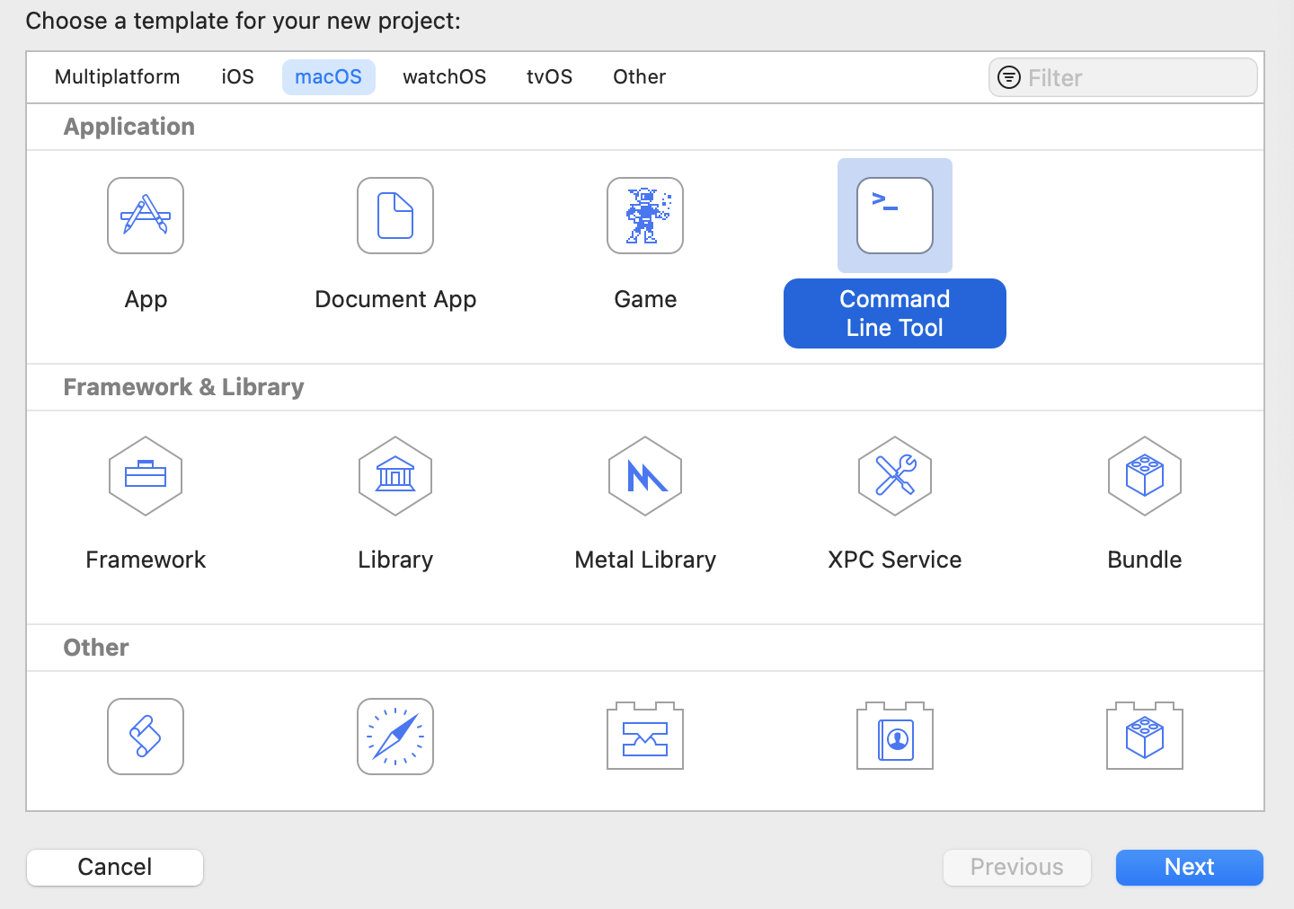

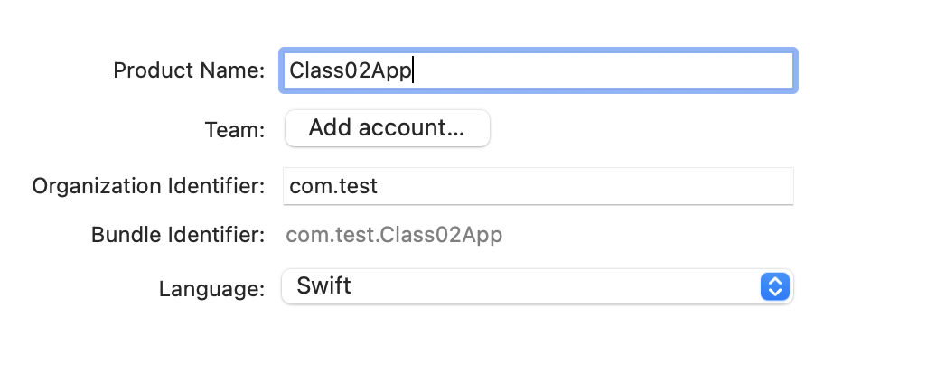

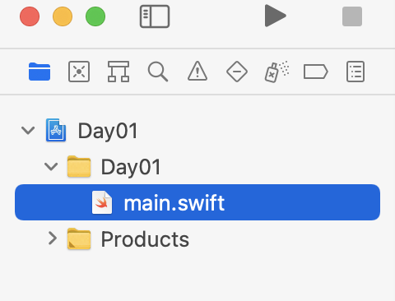

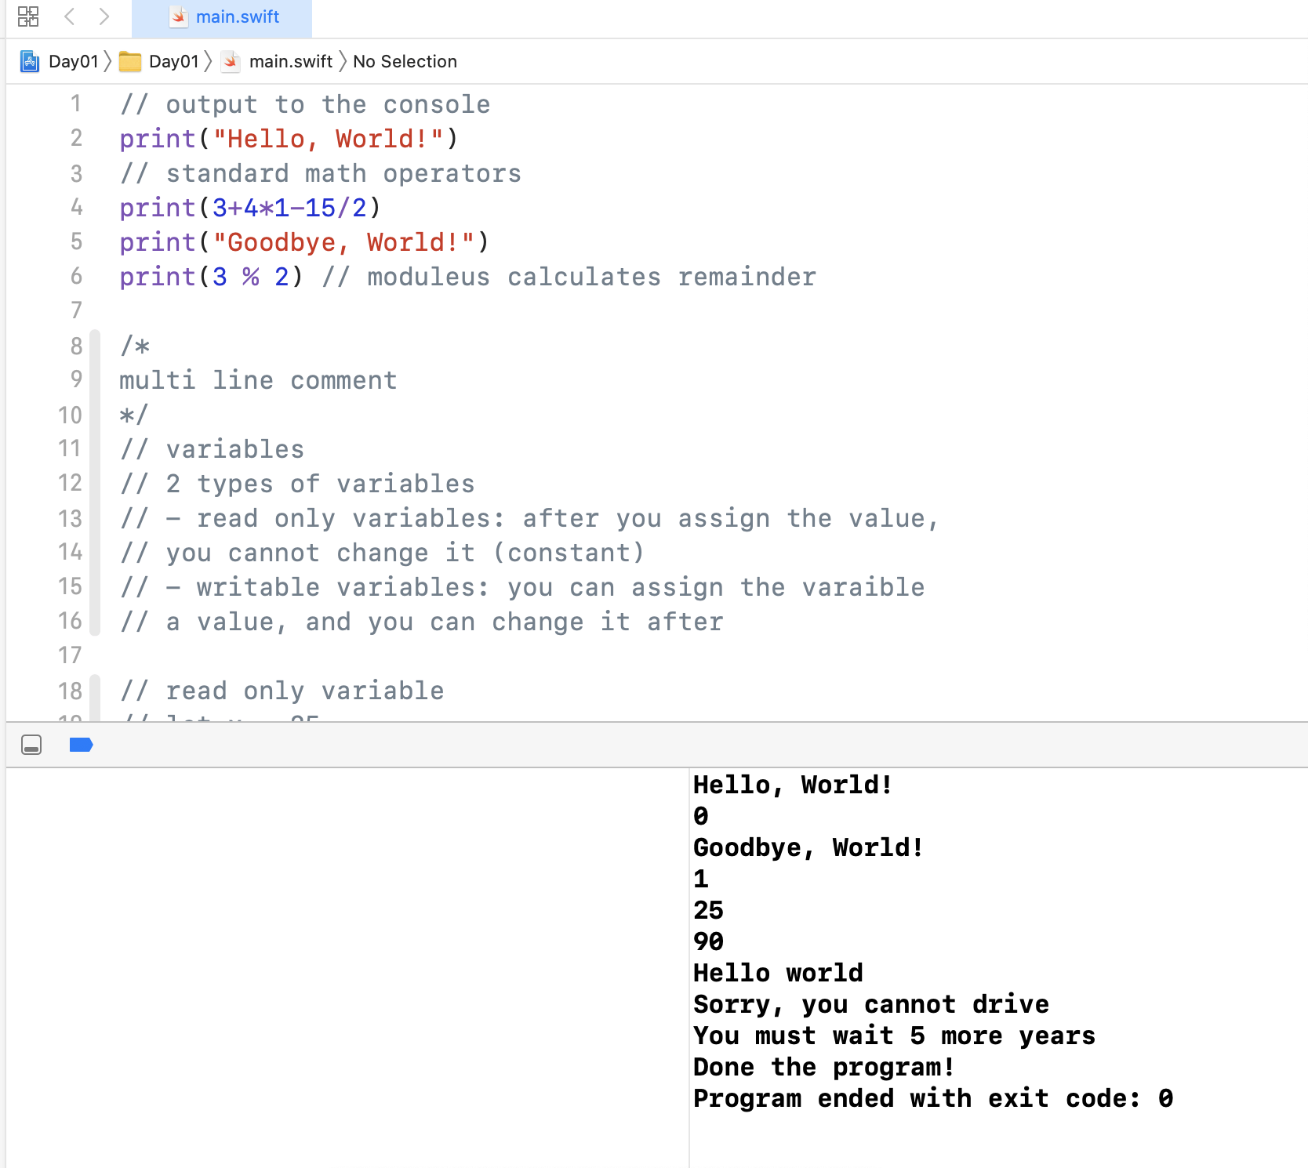

Conditional:

* Logical AND (&&)
* Logical OR (||)
* You can add as many else-ifs as you want to the conditional

let personAge = 25

if (personAge >= 17 && personAge <= 21) {

print("You can drive a beginner vehicle!!")

}

else if (personAge > 21) {

print("You can vote in some countries!")

}

else {

print("Sorry, you cannot drive")

print("You must wait \(17-personAge) more years")

}

print("Done the program!")

Switch

* Choose from a variety of conditions
* Conditions are based on == (gpa = 4, then A, gpa = 3.7 then B…)
* Multiple values can execute the logic (case: snowy, windy, hailstorm, etc)

let weather = "snowy"

switch (weather) {

case "rainy":

print("Bring an umbrella!")

case "snowy", "icy", "hailstorm", "windy":

print("Bring warm clothing")

case "sunny":

print("Have a beautiful day!")

default:

print("Error, I can't process this weather type!")

}

Loops:

* Count controlled loop: A loop that iterates a fixed number of times (for loop)
* Condition controlled loop: A loop that iterates based on a condition (while / do while )

Count Controlled Loop (For loop)

for i in 1...5 {

print("Loop #\(i): Hello world!")

}

// 1...5 : RANGE (... = inclusive range: it starts at 1 and includes 5)

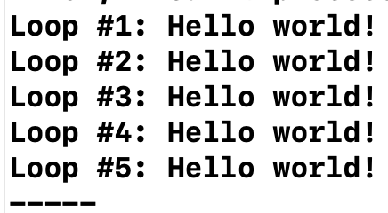

print("-----")

for i in 99...105 {

print("Loop #\(i): Hello world!")

}

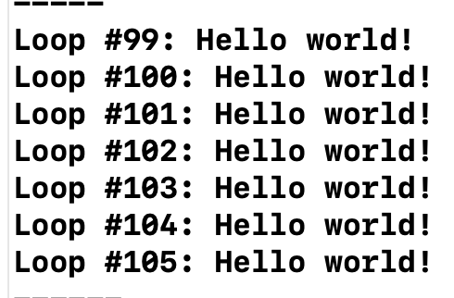

print("------")

// ..< : non-inclusive range: starts a 0 and ends at 3 (does not include the 4)

// for (let i = 0; i < 4; i++)

for i in 0..<4 {

print("Loop #\(i): Hello world!")

}

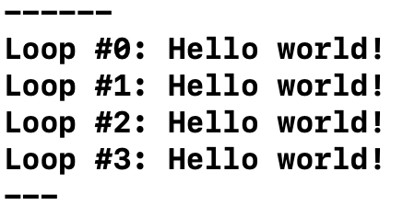

print("---")

for i in 99..<110 {

print("Loop #\(i): Hello world!")

}

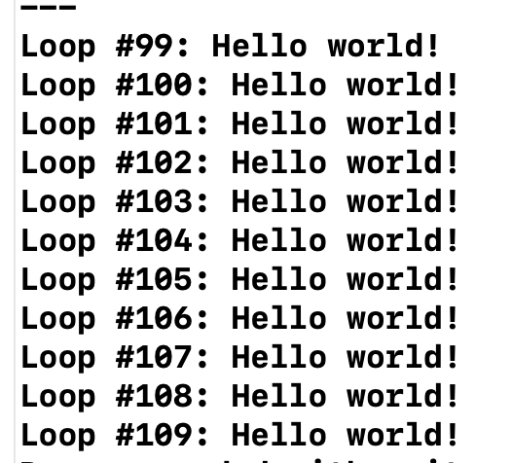

Reverse

print("-----")

for i in (1...5).reversed() {

print("Loop #\(i): Hello world!")

}

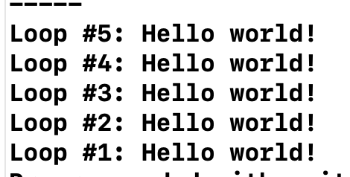

Condition controlled looop

* While loop
* Do-While → REPEAT WHILE

**While:**

var index = 0

while (index < 5) {

print("This is the way! \(index)")

index = index + 1 // ++ and -- operators don't work! bye!

}

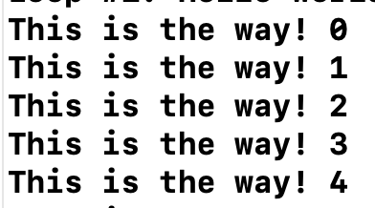

**Repeat Until (Do-while)**

// repeat-while

var numbers = 15

repeat {

print("Here is some output \(numbers)")

numbers -= 2

} while (numbers >= 0)

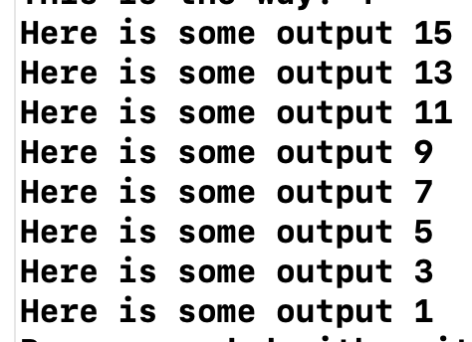

Break and continue work:

* Break: exit the loop early  
  Continue: skip the remaining code and go back to the top of the loop

var numbers = 15

repeat {

print("Here is some output \(numbers)")

numbers -= 2

if (numbers == 11) {

break

}

} while (numbers >= 0)

Array

var studentGrades = [50, 30, 80, 90, 100]

print(studentGrades)

// - explicit array delcariton (you specify what the data type of the array is)

// array operations

// - access a value

print(studentGrades[0])

print(studentGrades[1])

print(studentGrades[2])

print(studentGrades[3])

print(studentGrades[4])

// - update a value

studentGrades[0] = 100

print(studentGrades)

Iterate through your array

Using the index:

var friends = ["Peter", "Emily", "Abigail"]

for i in 0..<friends.count {

print("Your friend in position \(i) is \(friends[i])")

}

Using a for-in style loop

for person in friends {

print("Your friend is \(person)")

}

Using an index to modify items in the array permanently

var friends = ["Peter", "Emily", "Abigail"]

for i in 0..<friends.count {

print("Your friend in position \(i) is \(friends[i])")

friends[i] = friends[i] + " Smith"

}

print(friends)

Modifying the temporary variable

studentGrades = [0, 10, 20, 30, 40]

for var grade in studentGrades {

print("Original grade: \(grade)")

// update that grade

grade = grade + 20

print("New grade: \(grade)")

}

print(studentGrades)

Total number

// If you want get the total number of items in your array

print("You have \(friends.count) friends!")

// Is teh array empty?

print(friends.isEmpty) // return true if the array is empty, false otherwise

Add to array:

// add things to the array

var fruits = ["apple", "banana"]

print(fruits)

// add to the end of teh array

fruits.append("carrot")

fruits.append("donut")

fruits.append("eggplant")

print(fruits)

Add at a specific position

// add to a specific position

var animals = ["zebra", "pig", "cow"]

print(animals)

animals.insert("fish", at: 1)

print(animals)

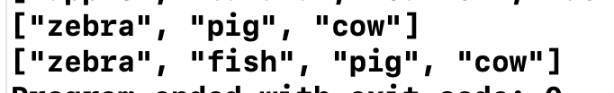

Removing an item

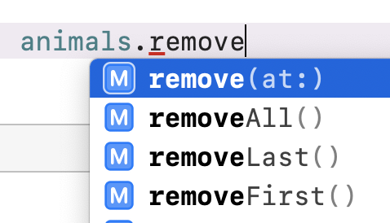

// remove an item at a specific position

animals.remove(at: 0)

print(animals)

// clear the entire arra

animals.removeAll()

print(animals)

print("The number of items is : \(animals.count)")

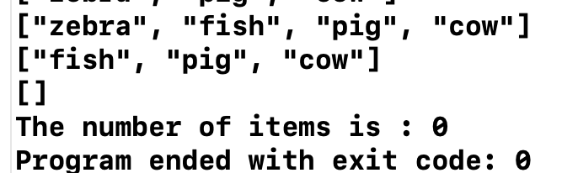

Reversing and sorting the array

animals = ["zebra", "pig", "watermelon", "dog"]

animals.reverse()

print(animals)

animals.sort()

print(animals)

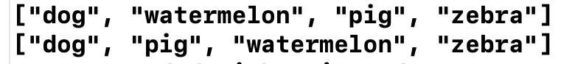

Declare an array implicitly or explicitly

// not okay

var cars:[String] = ["Kia", "Honda", 23432432]

// this is okay

// explicit array declartions

var cars:[String] = ["Kia", "Honda", "Toyota"]

var gpas:[Double] = [3.0, 4.21222, 1.855]

var isSleeping:[Bool] = [true, true, true, false, true, false]

// mixed array of data

var mixed:[Any] = ["Kia", 3.0, true, ["fish", "burger", "salad"], 555]

print(mixed)

Dictionary:

var dog:[String:Any] = [

"name":"Peter",

"breed":"Poodle",

"age":1,

"isSleeping":false

]

print(dog)

// access

print(dog["name"])

print(dog["age"])

// update

dog["name"] = "Rover"

print(dog)

// delete a key-value pair

dog["name"] = nil

print(dog)